battery v1 default specs
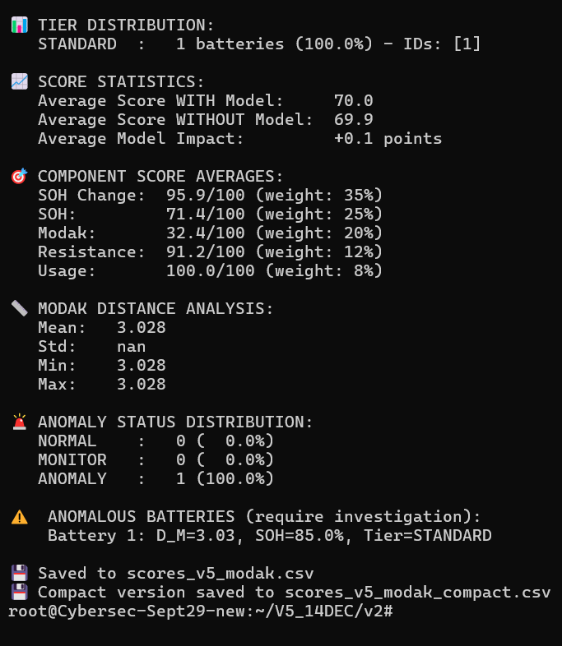

battery v3 600 batteries 250 epochs

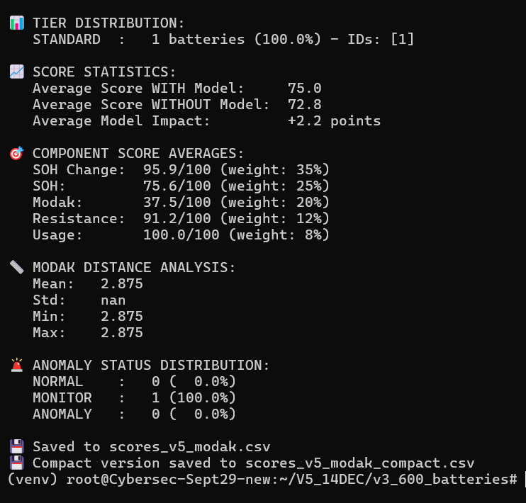

battery v4 1000 batteries 500 epochs

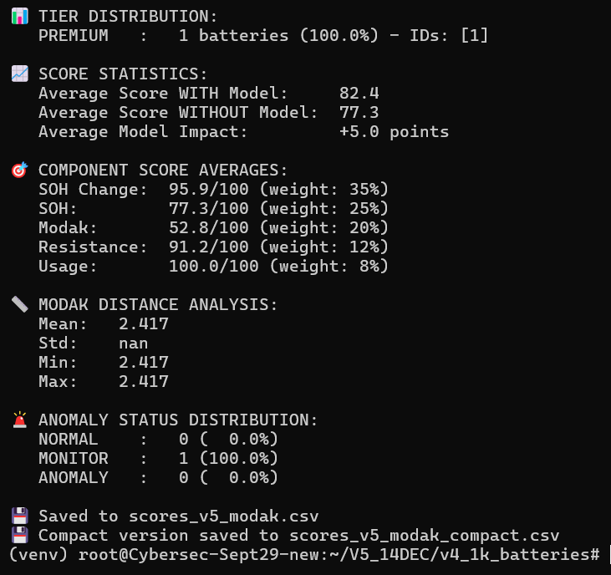

battery v5 2000 batteries 1000 epochs
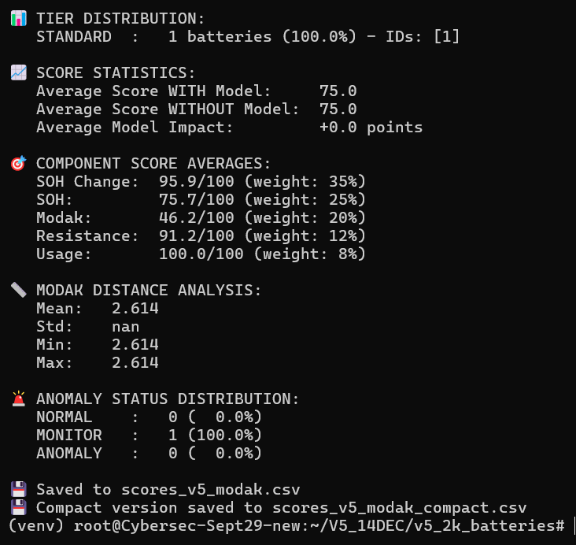

battery v6 5000 batteries 2000 epochs

